Study Guide – Cell Structure and Transport Exam
Review
- From the following examples, determine which STERNGRR characteristic is being described.
  - Autotrophic/heterotrophic organisms
  - The body eliminates ammonia through urine productions
  - The cell membrane is semi-permeable and allows certain particles to pass through.
  - Plants use the sun to make carbohydrates
  - Making energy in the mitochondria of a cell
- Using the data table and your knowledge of the pH scale, answer the following questions:
pH | Substance
7 | Pure water
2 | Stomach acid
13 | Bleach
4 | Tomato juice
10 | Soap

  - What substance is the strongest acid?
  - What substance is the strongest base?
  - Which substance has the most hydrogen ions?
  - What substance has a neutral pH?
- What are the four big macromolecules we have learned in this class and their monomers
- List the function of each of these macromolecules and draw the shape of each.
- Enzymes fit into which of the 4 macromolecules. What is another word we use for enzymes? What do enzymes do for a cell?
Objective 1: Discovery of the Cell
- What is the structure that makes up all living things?
- State the three concepts that make up the cell theory.
Objective 2: Prokaryotes and Eukaryotes
- Label each cell as either a prokaryote or Eukaryote. Explain why you labeled them as such.
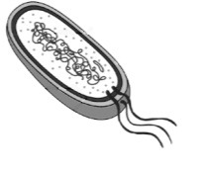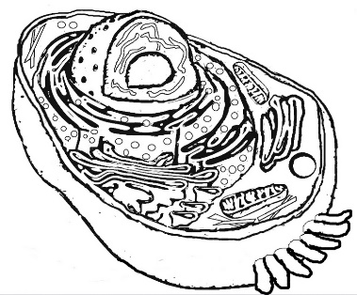
- Complete the Venn diagram below for Eukaryotes and Prokaryotes.
Prokaryotes Only | Both | Eukaryotes Only

- Give three examples of membrane bound organelles.
- Give an example of an organelle that does not have a membrane.
- Complete the chart below.
Category | Definition | Examples
 | Organisms whose cells lack nuclei
 | Organisms whose cells contain nuclei
- Complete the chart below.
 | Prokaryotic Cell | Eukaryotic Cell
Cell Membrane | Present
Nucleus |  | Present
Cell Size |  | Large
Complexity | Simple
Objective 3: Cell Structure
- Label the parts of the cell below.
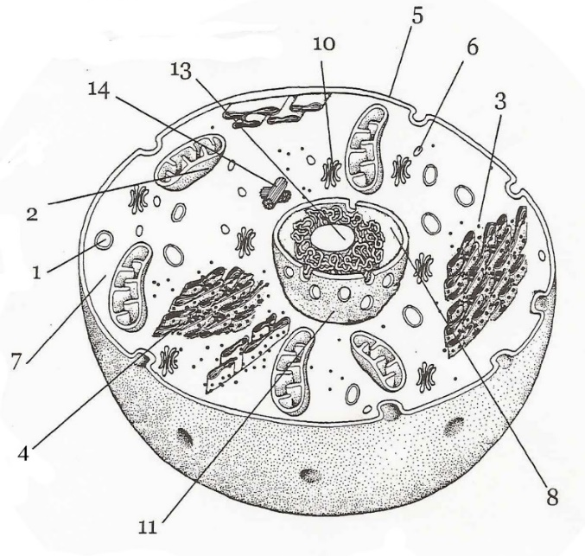
- What organelles might a scientist see inside a plant cell that would not be inside of an animal cell? Be able to explain why these cells are missing from the animal cell.

- What is the shape of a plant cell?
- What would happen to plant cells if they did not have a cell wall? What would happen to animal cells if they had a cell wall?

- Identify the structure. What is its function? Label the phospholipid bilayer and the proteins.
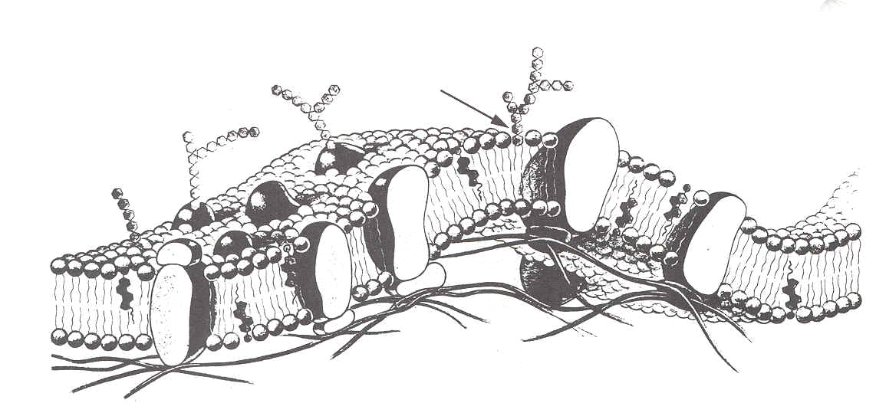

- What is the advantage of the cell membrane being selectively permeable?

- Complete the chart.
Organelle | Function
Nucleus
Nucleolus
Ribosome
Chromosome
Nuclear Membrane
Endoplasmic Reticulum
Golgi Body
Mitochondria
Chloroplast
Vacuole
Lysosome
Cell Membrane
Cytoplasm
Cell Wall

Objective 4: Cell Extras
- What is cell specialization? Provide three examples and draw pictures for each cell.

- Scientists know that a muscle cell that is constantly used contains many mitochondria, they also know that skin cells to not contain as many mitochondria. Why might this be?

- What are the three ways in which cells move? How are the different from each other?

- What are the two ways in which cells communicate? What are the differences between them?
Objective 5: Microscope
- A student wants to view cells under a compound microscope. If the eyepiece is 10x and the objective lenses are 4x, 40x, and 400x, what are the total magnifications the student can use to view the cells?
  - _________________x______________________=___________________
  - _________________x______________________=___________________
  - _________________x______________________=___________________
- If you look at an “e” under the microscope, what would it look like? Draw a picture below.

- Know how to label the parts of the microscope.
Objective 6: Cell Transport
- Explain the difference between osmosis and diffusion.
- Based on the picture below, is the concentration of Carbon dioxide greater inside the cell or outside the cell? Where is the concentration of oxygen greatest? Explain your answer.
CO2
O2
CO2
O2
O2
CO2
O2
CO2
O2
O2
CO2
O2
CO2

- A blood cell has the same concentration of solutes as seawater. What type of solution would the blood cell be in if you placed it into a beaker of seawater? What would happen to the cell?
- What would happen to the same red blood cell if you placed it in a beaker of pure water? Draw a picture and explain your answer in words.

- A student is studying what happens to red blood cells in different solutions. They put one red blood cell each in three different beakers. In the first beaker, the cell shrunk, in the second beaker it stayed the same, in the third is burst. What type of solution was the red blood cell sitting in for each of these scenarios? Draw a picture and use words to explain your answer.

- In the bloodstream, the concentration of oxygen is 80%. The concentration of carbon dioxide is 20%. In the cell, the concentration of oxygen is 15%. The concentration of carbon dioxide is 85%.
  - Use the red blood cell below to show the movement of molecules. Explain in words how they are moving into and out of the cell.

