NAME_______________________________________________________

|  |
| --- |
| **Goal 1: Learner will develop abilities necessary to do and understand scientific inquiry.** |

**1.01 Identify biological problems and questions that can be answered through scientific investigations.**

* 1. **Design and conduct scientific investigations to answer biological questions (create testable hypotheses, identify variables, use a control or comparison group when appropriate, select and use appropriate measurement tools, collect and record data, organize data into charts and graphs, analyze and interpret data, communicate findings).**

You have measured the rate at which a fish breaths at various temperatures by counting the rate at which its gills open. The data is below. Graph this data.

Breathing rate Temperature

19/min 5 deg C

25/min 10 deg C

30/min 20 deg C

34/min 30 deg C

37/min 35 deg C

What is the independent variable? The dependent variable?

What is the best type of graph for this data? Why?

What happens to breathing rate with increase in Temp?

What would be a good control for this experiment?

How do you think the breathing rate was measured?

What do you think would happen if you raised the

temperature even more?

Why would it be a bad idea to do this?

* 1. **Formulate and revise scientific explanations and models of biological phenomena using logic and evidence to: explain observations, make inferences and predictions, explain the relationship between evidence and explanation.**

An experiment was done that measured the Effects of Nitrates on the Growth of Algae. Growth of algae was determined by how well the water transmitted light. The less the light transmission, the greater the algae growth blocking the transmission of light.

Looking at the graph on the next page what conclusions can you draw about algae growth and nitrates in the water?

What other data would you like to have?

What would you predict would happen if this same data was gathered at the end of week 8?

Why do you think that nitrates have this effect on algae growth?

|  |
| --- |
| **Goal 2: Learner will develop an understanding of the physical, chemical and cellular basis of life.** |

* 1. **Compare and contrast the structure and functions of the following organic molecules:**

|  |  |  |
| --- | --- | --- |
| Macromolecules | Function | Subunits |
| Carbohydrates |  |  |
| Proteins |  |  |
| Lipids |  |  |
| Nucleic Acids |  |  |

|  |  |  |
| --- | --- | --- |
| Specific Molecule | Function | Subunits |
| Starch |  |  |
| Cellulose |  |  |
| Insulin |  |  |
|  |  |  |
| Glucose |  |  |
| Enzymes |  |  |
| Fats |  |  |
| DNA |  |  |
| RNA |  |  |

**Describe the following nutrient tests:**

|  |  |  |  |
| --- | --- | --- | --- |
| Nutrient | ***Type of Test*** | Negative Test | Positive Test |
| Starch |  |  |  |
| Lipids |  |  |  |
| Monosaccharides |  |  |  |
| Protein |  |  |  |

Explain the importance of shape to enzyme function.

Explain what determines the shape of an enzyme.

Explain why enzymes are specific.

**2.02 Investigate and describe the structure and function of cells including cell organelles, cell specialization, and communication among cells within an organism.**

**Fill in this chart. Also give the letter or number of the part as seen in the diagrams below.**

|  |  |  |
| --- | --- | --- |
| Cell Part and Letter | Structure Description | Function |
| Nucleus |  |  |
| Plasma Membrane |  |  |
| Cell wall |  |  |
| Mitochondria |  |  |
| Vacuoles |  |  |
| Chloroplasts |  |  |
| Ribosomes |  |  |

Which cell is the plant cell (left or right)?

Which structures are found only in the plant cell?

Which structures are found only in the animal cell?

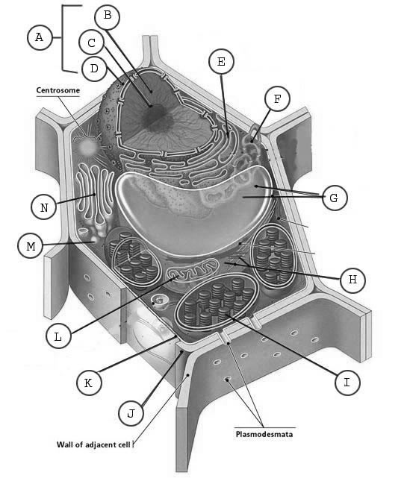

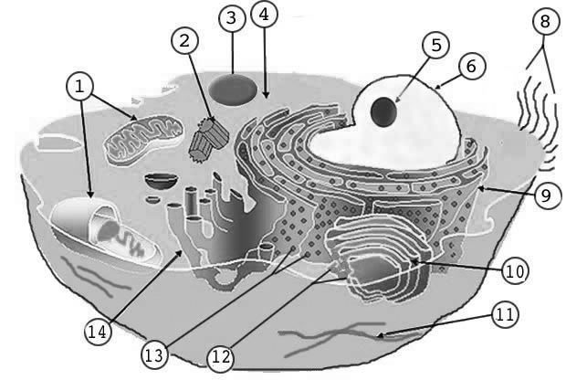

**Microscope Use:**

Put the following steps for making a wet mount slide in order.

1. Once the object is located, without moving the adjustment, change to medium power
2. Put the tissue on the slide
3. Switch to high power and bring the object into clear focus again.
4. Add a coverslip
5. Place the slide on the stage of the microscope
6. Add a drop of water
7. Try to locate the object using low power and coarse adjustment
8. Use fine adjustment to bring the object into clear focus.

1) ______ 2) ______ 3) ______ 4) ______ 5) ______ 6) ______ 7) ______ 82) ______

How do you determine total magnification of a microscope? (Assume the eyepiece magnifies 10 x and the objective magnifies 40 x)

Draw how the letter “e” would look as view through a microscope?

Put the following in order from smallest to largest:

Organ systems Cells Organs Tissues

___________ ___________ ___________ ___________

What is cell specialization?

What is cell differentiation?

When does cell differentiation occur?

**The diagram below shows many proteins and other molecules embedded in a cell membrane.** What are some of the functions of these proteins and other molecules?[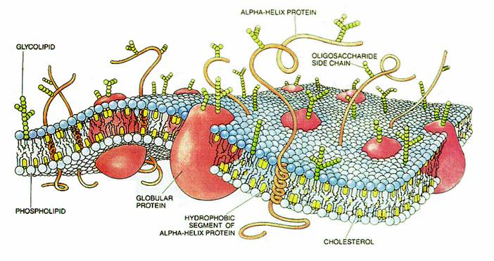](http://upload.wikimedia.org/wikipedia/commons/e/ee/CellMembraneDrawing.jpg)

**2.03 Investigate and analyze the cell as a living system including: maintenance of homeostasis, movement of materials into and out of cells, and energy use and release in biochemical reactions.**

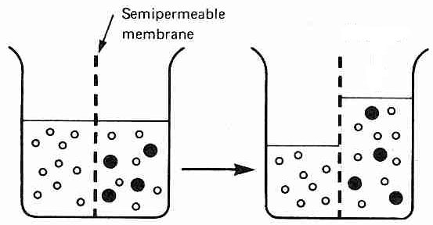Explain what has happened in the diagram to the left.

Why did the large dark molecules NOT move to the left?

How is the semipermeable membrane like a cell membrane?

If the dark molecule is starch, where is the starch concentration greatest (left or right)?

If the white molecule is water, where is the water concentration greatest at first?

In osmosis, water moves from an area of __________ to an area of _________ concentration.

If the dark molecules could move, in what direction would they move? Why?

In diffusion, molecules move from an area of ________ to an area of ________ concentration.

What is osmotic pressure?

Draw arrows to show which way **wate**r will move in each of the following situations:

* 1. Salt inside the cell = 65% and outside the cell 40%.
  2. Sugar inside the cell 27% and outside 80%.

What is homeostasis?

How do cells maintain homeostasis: Consider pH, temperature, blood glucose, water balance

**Comparison of active and passive transport**

|  |  |  |
| --- | --- | --- |
|  | **PASSIVE TRANPORT** | **ACTIVE TRANSPORT** |
| **Requires energy?** |  |  |
| **Low to high concentration or high to low concentration?** |  |  |
| **Examples** |  |  |

**Energy**

Use the following diagram to show where energy is released and where energy is used. Also use arrows on the lines attached to the circles to indicate the direction of the energy.

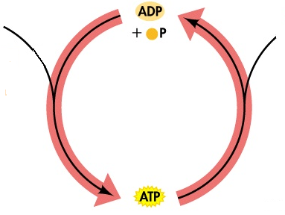

What cellular process produces ATP?

What is ATP energy used for? Give examples.

**2.05 Investigate and analyze the bioenergetic reactions: aerobic respiration, anaerobic respiration, and photosynthesis.**

Label the following molecules in these equations (water, glucose, oxygen, carbon dioxide, ethyl alcohol)

**A)** 

**B)**

**(Alcoholic Fermentation)**

**C)**

* Which of the above reactions is photosynthesis?
* Which of the above reactions is fermentation (anaerobic cellular respiration)?
* Which of the above reactions is cellular respiration (aerobic)?
* Which reaction(s) requires or stores energy?
* Which reaction(s) release energy (ATP)?
* Which reaction releases the most energy? Why?
* Which reaction requires chlorophyll? What is the purpose of the chlorophyll?
* Which reaction requires light? What is the light used for?
* Which organisms carry out process A?
* Which organisms carry out process B?
* Which organisms carry out process C?
* Which process uses chloroplasts in eukaryotes?
* Which process uses mitochondria in eukaryotes?
* What factors could speed up (or slow down) process A?
* What factors could speed up (or slow down) process B?
* What factors could speed up (or slow down) process C?
  1. **Investigate and describe the structure and function of enzymes and explain their importance in biological systems.**

What is the function of enzymes in biological systems? Why are they necessary for all biochemical reactions?

Explain why enzymes can be reused over and over again.

Why is there only one kind of enzyme for each biochemical reaction?

How do extreme pH and extreme temperature affect enzymes?

Draw the lock-and-key model of enzymes and substrates.

|  |
| --- |
| **Goal 3: Learner will develop an understanding of the continuity of life and the changes of organisms over time.** |

**3.01: Analyze the molecular basis of heredity including: DNA replication, Protein Synthesis (transcription and translation), and gene regulation.**

Below is a strand of DNA. DNA in the cells exists as a double helix – what else needs to be added to this strand to make it a double helix? Give the nucleotide sequence starting from the right (A) & moving to the left and ending with (G).

What are the black pentagons? What are the nitrogen bases?

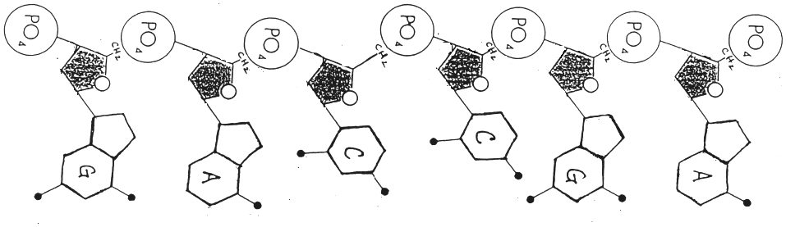

What kind of weak bonds hold the two strands of DNA together?

Why is it important that these bonds be weak?

**Cell Cycle:**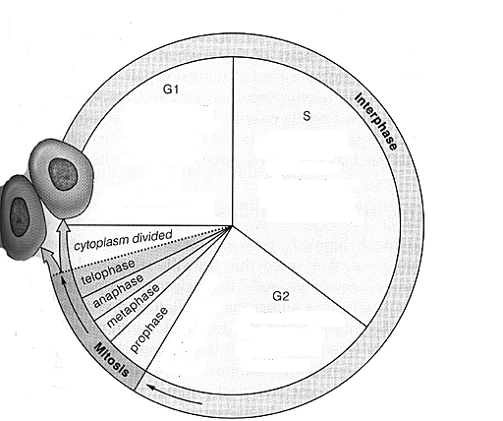

Look at the diagram of the cell cycle.

When does the duplication of DNA occur? What is this phase called?

What do GI and G2 represent?

Does mitosis include cytokinesis (division of the cytoplasm)?

Put the following stages of mitosis (cell division) in order.

