Cell Energy Practice Assessment
- What statement best compares aerobic and anaerobic respiration?
  - Less ATP is generated during aerobic respiration than during aerobic respiration
  - More water is generated during anaerobic respiration than during aerobic respiration
  - More oxygen is generated during anaerobic respiration than during aerobic respiration
  - Less lactic acid is generated during anaerobic respiration than during aerobic respiration
- Energy is released from ATP when
  - A phosphate group is added
  - Adenine bonds to ribose
  - ATP is exposed to sunlight
  - A phosphate group is removed
- Looking at the figure 8-1, all of the following are parts of an ADP molecule EXCEPT
  - Structure A
Figure 8-1
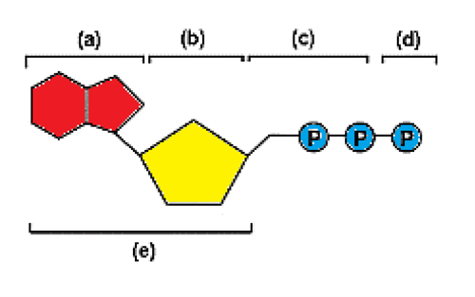
  - Structure B
  - Structure C
  - Structure D

- Looking at the figure 8-1. Which structures make up an ATP molecule?
  - A and B
  - A, B, and C
  - A, B, C, and D
  - C and D
- Which structure in figure 8-1 is a sugar molecule?
  - Structure A
  - Structure B
  - Structure C
  - Structure D
- Which of the following are used in the overall reactions for photosynthesis?
  - Carbon dioxide
  - Water
  - Light
  - All of the above
- Which of the following is not a part of the ATP molecule?

  - Adenine
  - Ribose
  - Chlorophyll
  - Phosphate

- Photosynthesis uses sunlight to convert water and carbon dioxide into
  - Oxygen
  - High energy sugars
  - ATP and oxygen
  - Oxygen and high energy sugars

- Plants gather the suns energy with light-absorbing molecules called
  - Pigments
  - Glycolysis
  - Chloroplasts
  - Glucose
- What are the reactants in the equation for cellular respiration?
  - Oxygen and lactic acid
  - Carbon dioxide and water
  - Glucose and oxygen
  - Water and glucose
- One cause of muscle soreness is
  - Alcoholic fermentation
  - Glycolysis
  - Lactic acid fermentation
  - The Krebs’s cycle
- Which organism is not likely to carry out photosynthesis?
  - Algae
  - Bacteria
  - Plants
  - Amoeba
- Cellular respiration uses one molecule of glucose to produce
  - 12 ATP molecules
  - 0 ATP molecules
  - 36 ATP molecules
  - 8 ATP molecules
- Photosynthesis is to chloroplasts as cellular respiration is to
  - Chloroplasts
  - Cytoplasm
  - Mitochondria
  - Nucleus
- Which of these processes takes place in the cytoplasm of a cell?
  - Glycolysis
  - Electron transport chain
  - Krebs cycle
  - All of the above
- The two main types of fermentation are called
  - Alcoholic and aerobic
  - Aerobic and anaerobic
  - Alcoholic and lactic acid
  - Lactic acid and anaerobic
- Cellular respiration can be called an aerobic process because it requires
  - Light
  - Exercise
  - Oxygen
  - Glucose

