Terms to be used only once:

- Amino Acids
- Animals
- Carbohydrates
- Cell Membrane
- DNA
- Disaccharide
- Egg
- Energy Storage
- Enzymes
- Fructose
- Glucose
- Glycogen
- Hemoglobin
- Lactose
- Lipids
- Monosaccharide
- Nitrogen Base
- Nucleotide
- Nucleic Acid
- Phosphate Group
- Phospholipids
- Plants
- Polysaccharide
- Proteins
- Saturated
- Starch
- Sucrose
- Unsaturated
- 5-Carbon Sugar
- Triglycerides
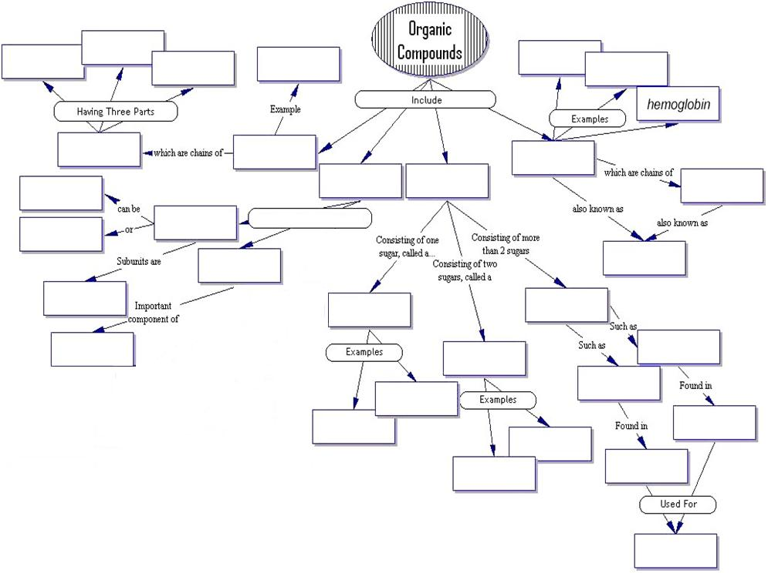
Includes 2 Groups

